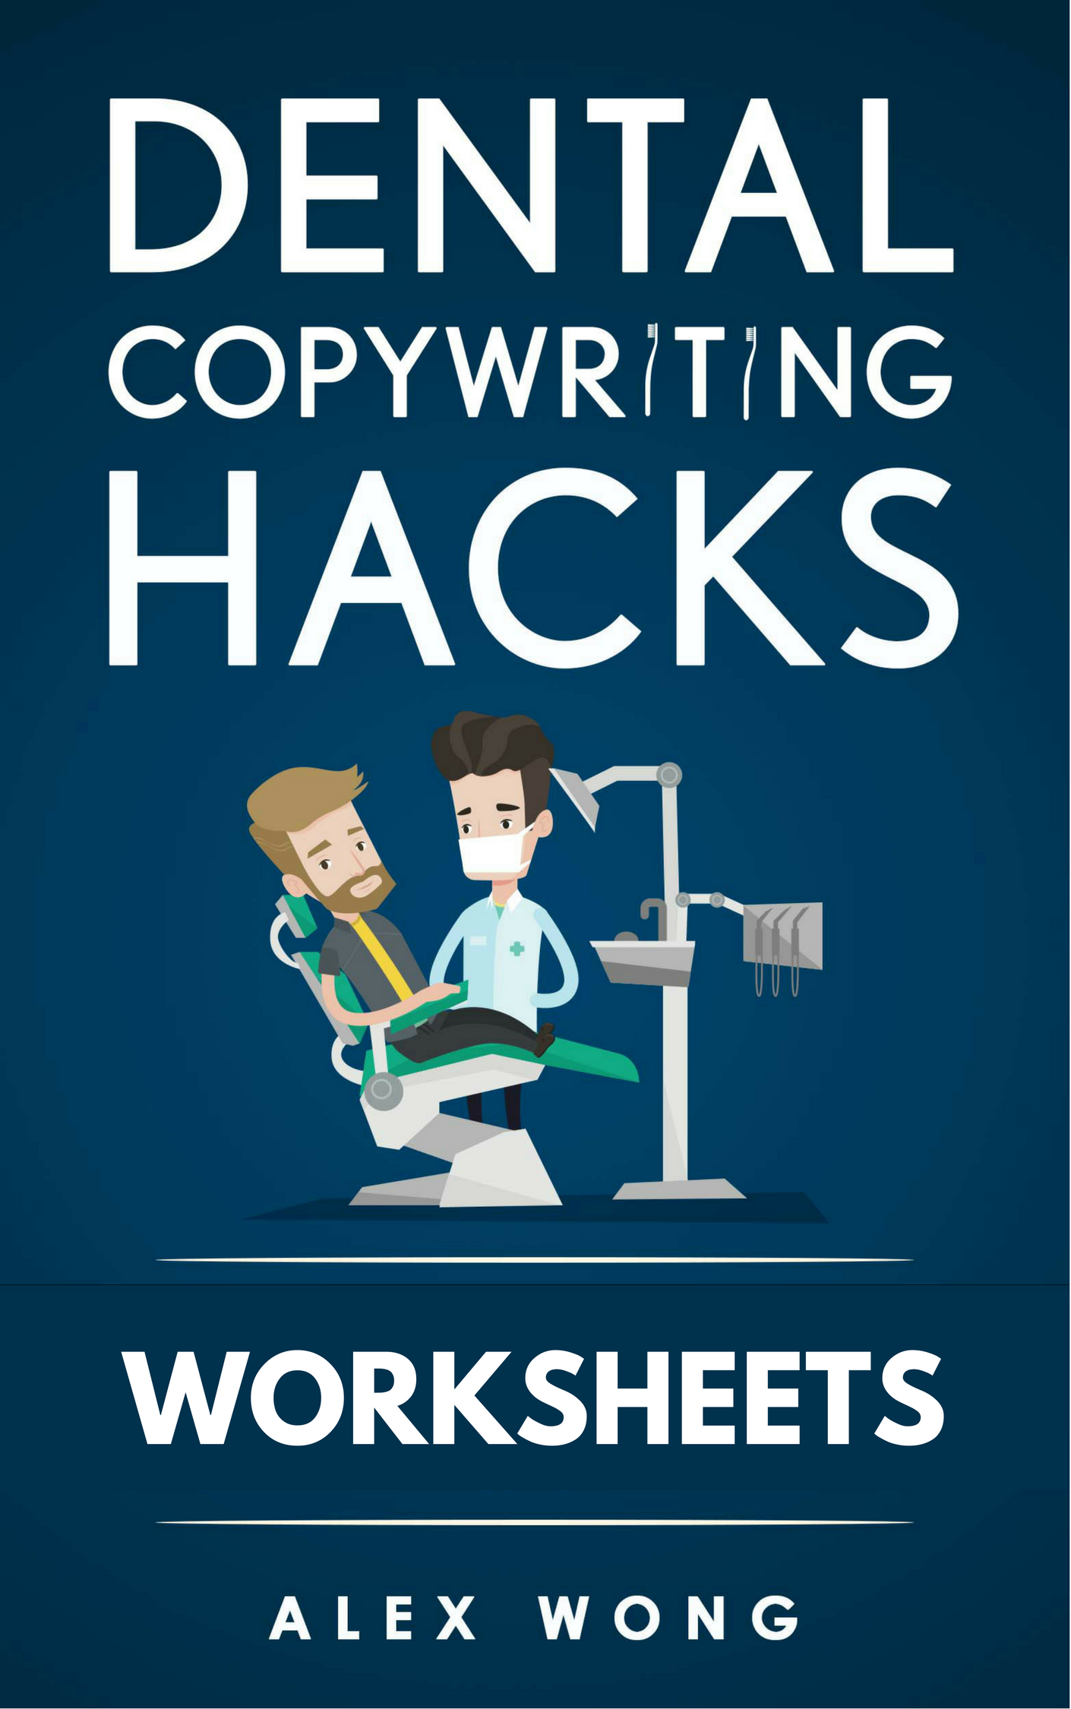

NOTE:
These worksheets are from my book, Dental Copywriting Hacks: A Complete Blueprint to Marketing and Growing your Online Dental Practice.
To get the most value from them, I recommend using them in conjunction with my book, which you can get here:
http://bit.ly/dentalcopywritinghacks

Publication Details
Written by Alex Wong
www.alexwongcopywriting.com
Version 1.00

Copyright © 2018
All rights reserved. This book or any portion thereof
may not be reproduced, shared or used in any manner whatsoever
without the express written permission of the author or publisher.

Action Plan: Create Your Prospect Avatar
A prospect avatar is an imaginary person that represents your ideal customer. You want to know your prospects well so you can know how to effectively sell to them. The more that you know about your prospects, the easier and more effective your sales copy will be.
Answer the questions below to complete your avatar’s profile. Give your avatar a name, occupation, hobbies, and other personal details. Be as detailed as you can be to make your avatar come to life.
Remember, if you have multiple practices aimed at different types of patients and customers, create a different avatar for each one since each avatar will be a different person.
Once you have created your prospect avatar, print it out and refer to it when writing your website’s sales copy.
Name:
Photo of your Avatar
Age:
Occupation:
Education:
Hobbies:
1.
2.
3.
What are 5 of their character traits?
1.
2.
3.
4.
5.
What are their 3 biggest fears?
1.
2.
3.
What are some frustrations they’re dealing with?
1.
2.
3.
What are their desires?
1.
2.
3.
What are 3 things they want?
1.
2.
3.
What are 3 things they want to avoid?
1.
2.
3.
What’s their main purpose for their visit?

Using the answers from above, write your avatar’s profile description. Remember to be as specific and detailed as possible:

Action Plan: Position Yourself In The Marketplace
Effective positioning helps you to stand out from other dental practices. It creates a positive image of you and your practice in your target customer’s mind and influences their perception of what you have to offer in relation to your competitors.
Step 1:
Conduct market research and ask your patients why they chose your practice, what they liked/disliked, what can be improved, and their overall experiences.
I’ve included a chart to help get you get started. Keep in mind this list is just a starting point and you can get a lot more in-depth with your customer research.
Things liked | Things disliked | Overall experiences | Areas for improvement | Common themes

Step 2.
Write out 3 ways you can provide more value to patients.
1.
2.
3.

Step 3:
Check out your top competitors and see how they have positioned themselves in the marketplace.
Competitor 1.

Competitor 2.

Competitor 3.

Step 4.
Jot down 3 different ways you can position your practice that differentiates yourself from your competitors. Remember, it’s better to position your practice in an area where your competitors show some weakness.
1.
2.
3.

Action Plan: Create A USP Statement That Will Demolish Your Competitors

A USP statement is a short sentence or paragraph that shows the unique benefits and advantages that your practice offers.

Step 1: Write 5 possible headlines for your USP statement
Before you start writing your headline, refer back to your customer avatar and review their needs, desires, and problems. What are some problems they are struggling with? What do they desire? What are some objections they may have?
You can use one of the headline templates to help create your headline.
1.
2.
3.
4.
5.

Step 2: Write a subheadline for each headline
To write your subheadline, focus on clarifying and supporting the headline. You can state what your offer is in the headline and add the benefit or problems you avoid in the subheading (or vice-versa).
1.
2.
3.
4.
5.

Step 3:
List a few of the main products or services that you offer. For each service, write out all of the unique benefits that it provides to patients.

Product/Service | Benefits
1.
2.
3.
4.
5.
Product/Service | Benefits
1.
2.
3.
4.
5.
Product/Service | Benefits
1.
2.
3.
4.
5.

Step 4: Write 10 benefit-focused bullet points

- Focus on the benefits and the problems you solve
- Start off with your biggest benefits and work your way down to less important ones
- Write in sentence fragments
- Keep your bullets clear, focused, and specific
- Keep your bullets' structure consistent
1.
2.
3.
4.
5.
6.
7.
8.
9.
10.

Step 4: Choose your best headline, subheadline, and 3-5 bullet points to use as the USP

Action Plan: Write Your Website Copy

Action plan 1: Write the copy for your homepage
- Determine what action you want visitors to take and make that your main call-to-action. Put the call-to-action after the USP statement
- Use the headline, subheading, and bullets you wrote for your USP as the main copy for your homepage
- If you offer multiple products and services, you can add a couple of paragraphs to expand on your USP and message
- Make it easy for readers to find what they’re looking for by linking to the pages they’re most likely to visit

- Include third-party seals from dental organizations that you’re a part of and patient testimonials to build credibility and trust

- Write to your customer avatar to make your copy focused and engaging

Action Plan 2: Write An Engaging About Us page

Step 1: Write your about us page
When writing your about page, don’t just talk about your practice or services. Instead, show how you can help your visitors with their problems.
Things to keep in mind:
- Focus on your target prospect
- Work in your USP statement and positioning
- Include a specific call-to-action
- Include stories about yourself and practice to connect with readers. When crafting your short story, here are a few questions to ask yourself:
  - Who are you and what makes your practice special?
  - What was your motivation for opening and operating your practice?
  - What challenges did you and your team face?
  - How does your practice make a positive change?
  - What are your goals for the future?
  - How do you want to help your patients?

Action Plan 3: Write High-Converting Service Pages
Step 1: Decide how many service pages you need
The number of service pages you have will depend on the number of services that you provide
Step 2: Write your service pages
Things to keep in mind for your service pages:
- Describe the process to your readers. Remember, focus on informing and educating your readers to get them comfortable using your service

- Address any objections your patients may have about the service. Are they worried about the pain? Do they think it may be too expensive?

- Aim for at least 300 words for each service page

- Relate how each service benefits your prospects and what problems they help solve

- Try to keep your page titles to no more than 65-70 characters, including spaces to ensure they show up properly in Google’s SERPs

- Research relevant specific keywords for your pages. Once you have a good idea of what keywords to use, “sprinkle” them throughout your web pages

- Build your credibility by including testimonials and stats

- End with a strong call to action to get patients to contact you

Feel free to use the boxes below to write your service pages or use your preferred typing program.

Action Plan 4: Create Your Contact Page
Let your readers know how they can contact you and when they should expect a reply.
Include your practice’s address and contact details, such as phone number and email.
Include a Google map of your practice's location so that visitors can check how to reach your practice.
Include landmarks, major intersections, and directions to make it easy to find your practice.

Action Plan 5: Write An Informative FAQs Page
Step 1: Think of all the common questions that patients ask you. I recommend having at least 10 questions for your FAQs list.
Step 2. Answer each of your questions.
Step 3: Address potential objections or fears that your prospects may have about seeing you.
Step 4: Organize your FAQs list. Put your most commonly asked questions at the top and less common or more complex questions further down at the bottom.
Step 5: If you have a lot of questions for your list, group related questions together to make it more scannable and organized
Step 6: Link to other pages on your website when creating your FAQs. All you have to do is write a question related to one of your other pages and include a hyperlink to that page when answering the question.

Related Books
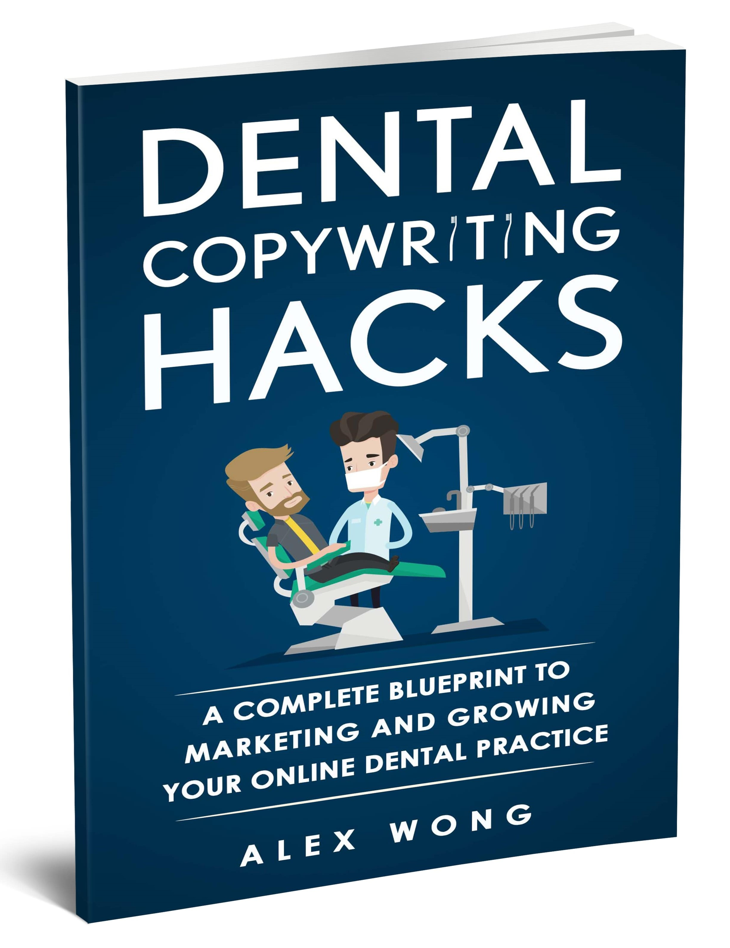
How do you create a homepage that grabs readers' attention?
How do you build an About page that builds trust and credibility?
And how do you create high-converting service pages that get clicks?
If you want a simple, actionable and practical way to create profit-boosting website content, check out my book: Dental Copywriting Hacks: A Complete Blueprint to Marketing and Growing your Online Dental Practice.
This is a step-by-step guide to dental copywriting that shows you how to create compelling website content to get more visibility, inquiries, and patients. My approach leverages the power of sales copywriting and consumer psychology to win you more business.
Are you ready to take your dental practice to the next level?
Get your copy now here.
Or visit: http://bit.ly/dentalcopywritinghacks

Blogging Hacks For Dentistry:

How To Engage Readers And Attract More Patients For Your Dental Practice
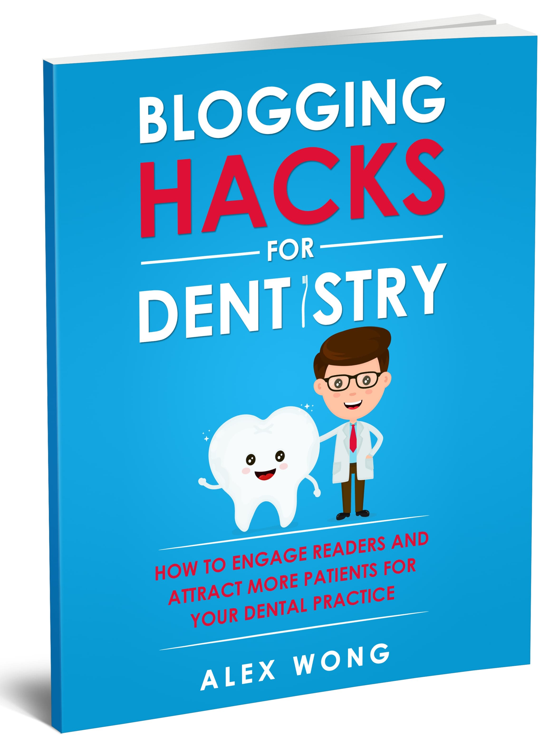
How do you create dental blog content that readers will love and keep them coming back for more?
And how do you position your blog so that it stands out in an overcrowded blogging sphere?
If you want an easy and simple way to create viral blog content, check out my book: Blogging Hacks For Dentistry: How To Engage Readers And Attract More Patients For Your Dental Practice.
This is a practical guide to dental blogging that shows you step-by-step how to create blog content that attracts more leads, prospects, and sales.

Get your copy here.

Or visit: http://bit.ly/blogginghacksfordentistry

About Alex Wong
Alex Wong is the “Hijack” Copywriter and founder of Alex Wong Copywriting. He helps you capture more leads and sales by "hijacking" your prospects' minds with irresistible content. He’s on a mission to win you more customers and make you stand out from the competition.
Whether you’re a small business or corporate, it doesn’t matter. He’ll work with you to ensure your copy needs are met and deliver the best results possible.
Would you like to get in touch? Email me: alex@alexwongcopywriting.com

Professional Dental Copywriting Services
Want attract more patients and grow your online dental practice? I can help.
I’m a dental copywriter, oral health enthusiast, and I’ve helped dozens of dental practices improve their online content. I can discover what makes yours special.
As a professional dental copywriter I can help:
- Drive visitors to your dental website
- Set your practice apart from the competition
- Build your credibility and trust with your readers
- Improve your ranking on search engines
- Give back your valuable time
I offer a variety of copywriting services to grow your practice including website copywriting, content marketing, email copywriting, blog posts, newsletters, and more...
I’d love to help grow your practice and take it to the next level.
So, are you ready to get more patients?
Supercharge your Dental Website Copy Today
Or visit: http://alexwongcopywriting.com/dental-copywriting/

